MedBook

Use-Case Specification

Version 1.1

Revision History

| **Date** | **Version** | **Description** | **Author** |
| --- | --- | --- | --- |
| 10/12/21 | 1.0 | Complete UI design | NPVy, NPChien, NNDu, HNMDuc, NKTTNga |
|  |  |  |  |
|  |  |  |  |
|  |  |  |  |

Table of Contents

1. Sign Up Screen 4
2. Log In Screen 6
3. Forgotten password Screen 7
4. Send OTP Screen 8
5. Change password Screen 1 9
6. Change password Screen 2 10
7. Home and News Screen 11
8. Notification Screen 12
9. Booking Screen 13
10. Booking Successful 14
11. Follow-up examination Screen 14
12. Edit Appointments Screen 15
13. View History Appointments Screen 17
14. View Upcoming Appointments Screen 18
15. Profile Screen 19
16. View hospital information Screen 20
17. View doctor information Screen 22

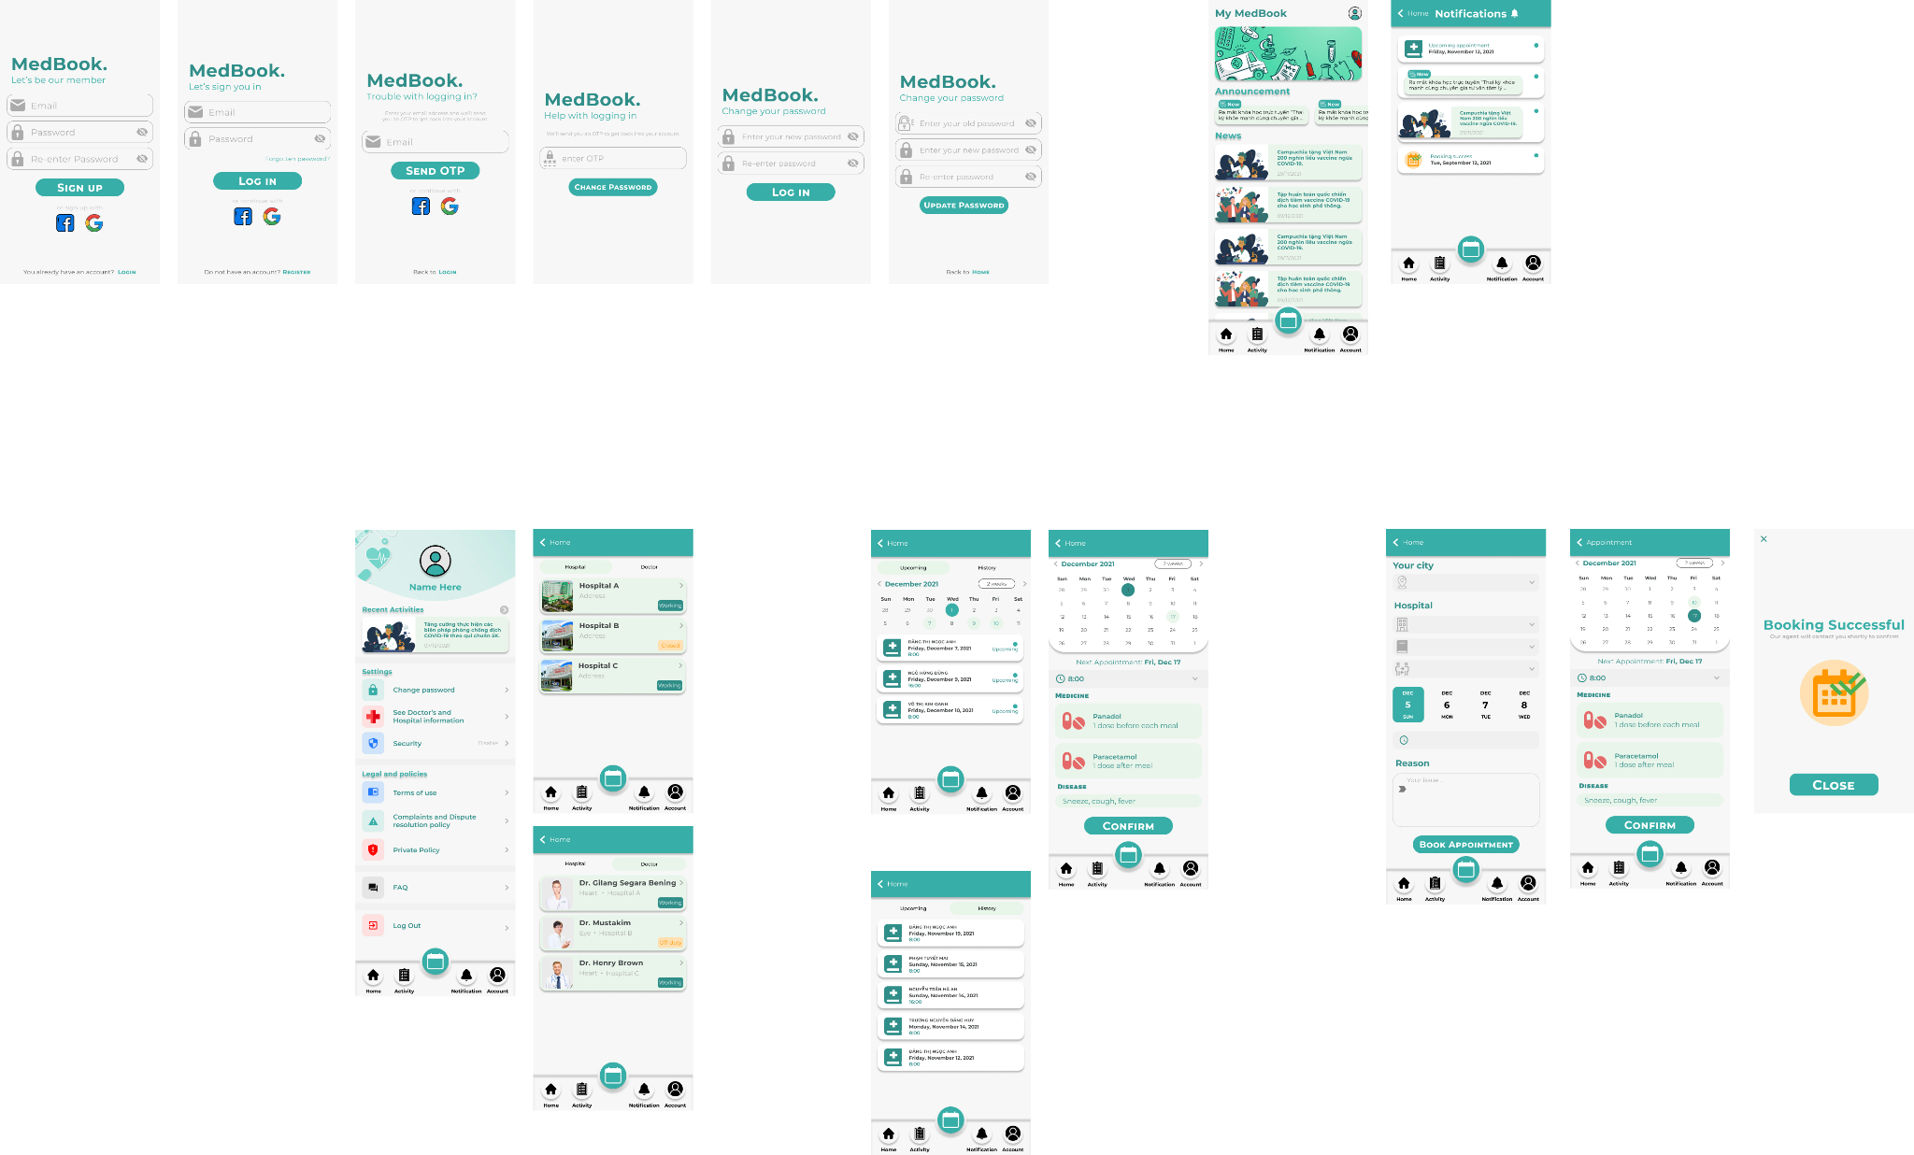

<https://www.figma.com/file/WdRtIpBCS4FtvuU3CiKpzx/SE?node-id=2%3A5>

# Sign Up Screen

Sign up for new user using email or social media (facebook, google)

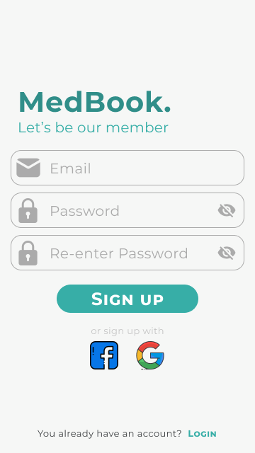

# Log In Screen

User can use their registered email address, Facebook or Google account to Log In.

# Forgotten password Screen

If password is forgotten, enter email in order to receive an OTP to reenter into your account.

# Send OTP Screen

After entering you email address on the Forgotten password screen, user will be redirected to this screen then enter the OTP is sent to their email address.

# Change password Screen 1

This screen will be displayed after successfully entering the valid otp code.

User must change their password.

# Change password Screen 2

This screen will displayed after choosing “Profile Screen → Change Password” to change user’s password if needed.

# Home and News Screen

This screen is for being up to date with medical news.

# Notification Screen

This screen is for notifying users with medical news or upcoming appointments.

# Booking Screen

Allow user to choose location, hospital, doctor and time to come to the hospital in order to avoid time-consuming.

# Booking Successful

This screen notified the user about their booking with the doctor through our application is successfully.

# Follow-up examination Screen

This page allows doctors to edit or add medicine, disease of each patient available in list.

# Edit Appointments Screen

This page allows patients to rearrange the date and time of an appointment.

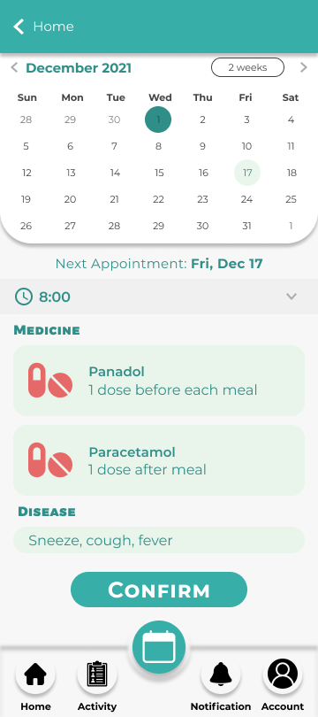

# View History Appointments Screen

Patients can view their Done appointment list in this page.

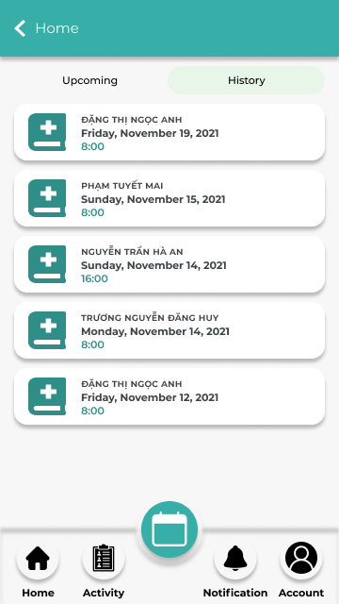

# View Upcoming Appointments Screen

Patients can view their Upcoming appointments on this screen

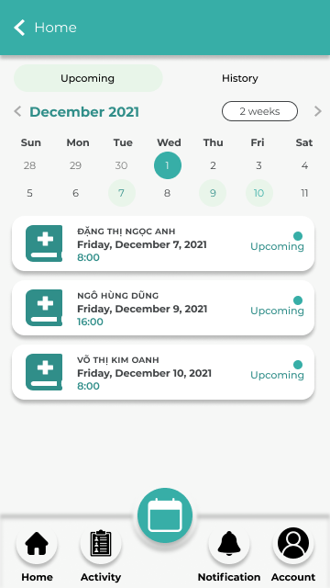

# Profile Screen

**Settings** tab allows you to change password, see doctors’ and hospital information and enable security.

**Legal and policies** tab users can get information about our app’s terms of use, complaints and dispute resolution policy private policy.

If users have any questions about our app, feel free to ask in the **FAQ**.

The **Log Out** will return user to Log In Screen.

# View hospital information Screen

View information about hospitals that connect with our app.

# View doctor information Screen

View doctors’ information working in those hospitals mentioned above.

